
SPECIALIST MATHS
TRIAL EXAMINATION 2
SOLUTIONS
2005

_____________________________________________________________________

Question 1
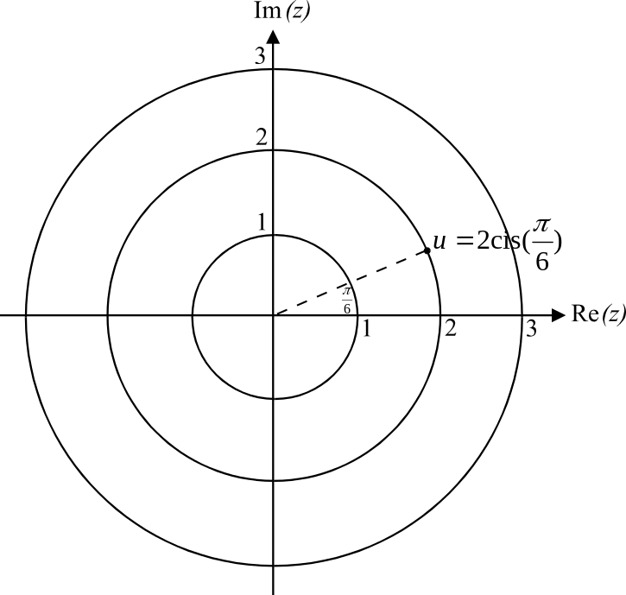
- i.

(1 mark)

- The roots of the equation 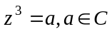, are evenly spaced around a circle. Since we know that one of the roots is u, the circle has a radius of 2 and the roots are spaced 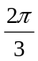 apart. So since 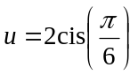, the second root is 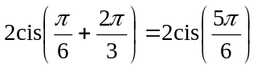 and the third root is 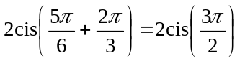 or 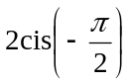.
(2 marks)

- Method 1
(1 mark)
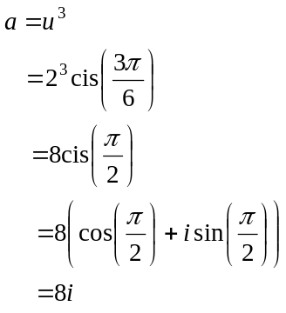
(1 mark)

Method 2
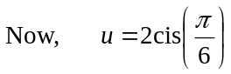
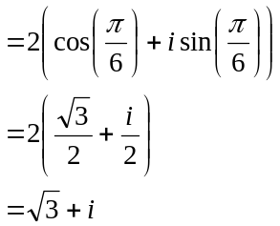
From part ii. we know that the second root; 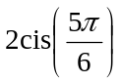, is a reflection of 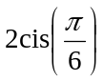 in the y- axis. Therefore the second root must be a reflection of 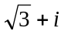 in the y-axis.
The second root is therefore 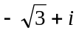 and the third root is –2i. (1 mark)
So,
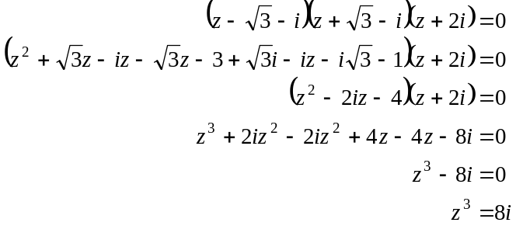
So 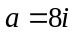.
(1 mark)

- i. Method 1
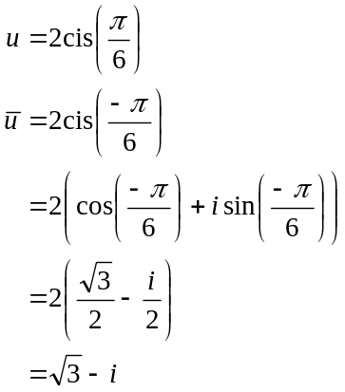
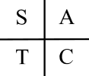

Method 2
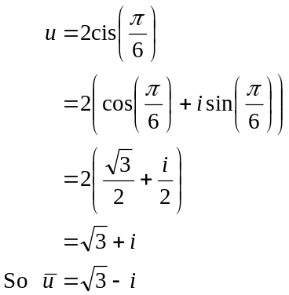
(1 mark)

- 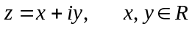
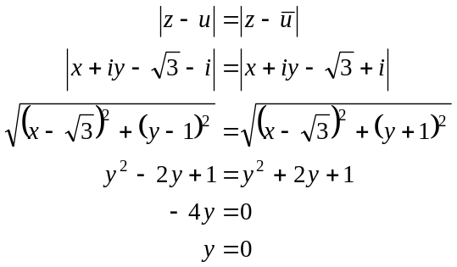
(1 mark)
(1 mark)

iii.
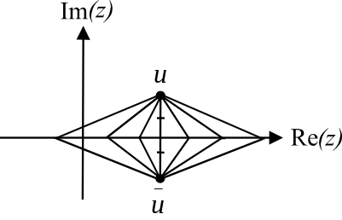

If 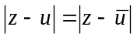 then the distance from the
complex number z to the complex number u is
the same as the distance from z to the complex
number .
From the diagram, those complex
numbers z for which this applies, lie along
the real axis of the Argand diagram.
So 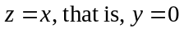.
(1 mark)
Total 9 marks
Question 2

- Draw a diagram showing all the forces.
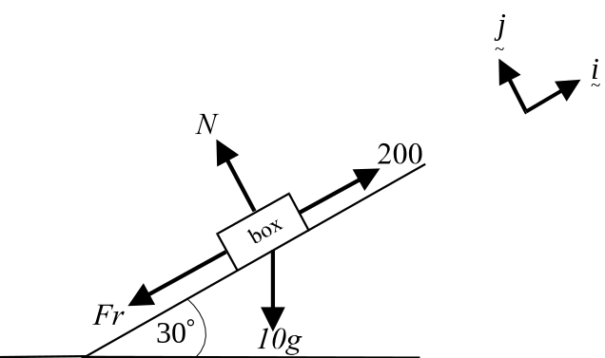

(1 mark)

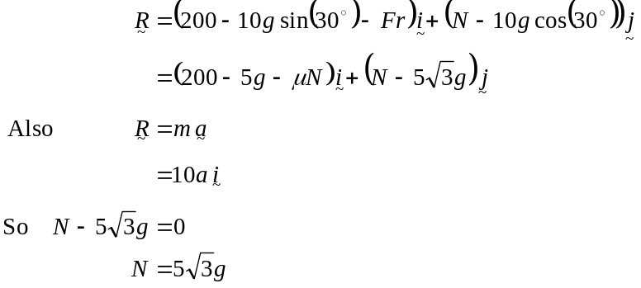
(1 mark)
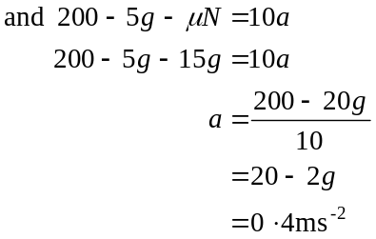
(1 mark)
(1 mark)

- Since the acceleration is constant, we can use the formula
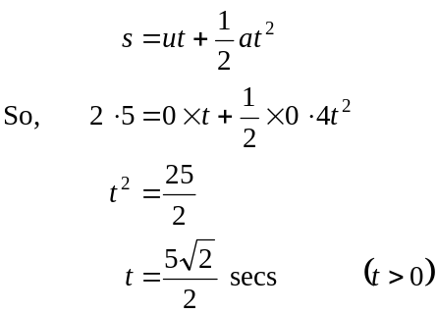
(1 mark)
(1 mark)

- Draw a diagram showing all the forces.

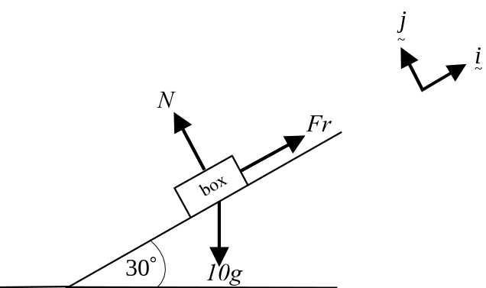

(1 mark)

There is now no pulling force up the ramp and so the tendency of the box would be to slip down the ramp and so the friction forces are directed up the ramp.
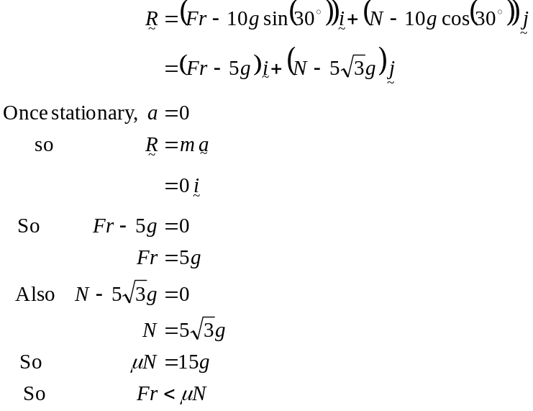
(1 mark)
So the box is not on the point of slipping down the ramp.
(1 mark)

- From part c., we have
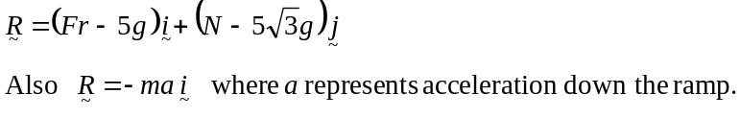
(1 mark)
So,
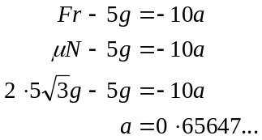
(1 mark)

Since the acceleration is constant,
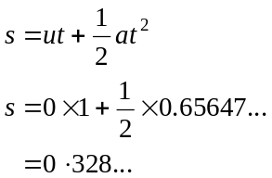
The box travels 33cm (to the nearest centimetre) in the first second.
(1 mark)
Total 12 marks

Question 3

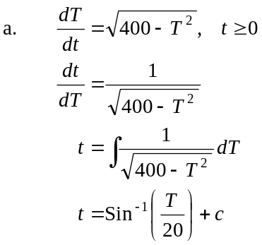
(1 mark)
(1 mark)
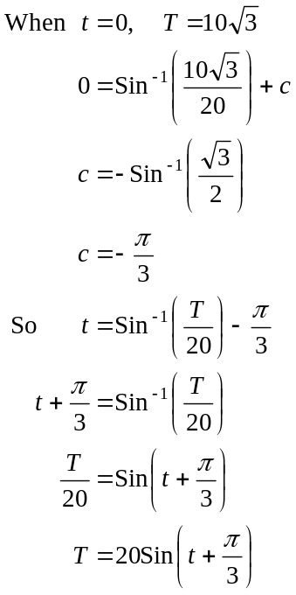
(1 mark)
(1 mark)

- Since the function 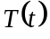 contains the principal valued sin function, then
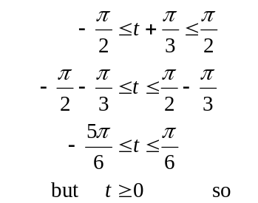
we require 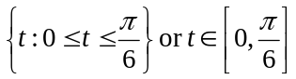.
(1 mark) – upper limit
(1 mark) – lower limit

- 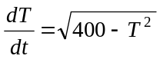
The sign of 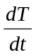 can only be positive. Hence the gradient of the function is always positive and hence the temperature increases as time increases and hence the maximum temperature occurs at the upper limit of the domain of the function 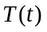; that is, at 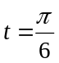.
(1 mark) – stating is always positive
(1 mark) – rest of explanation

(1 mark)

Total 8 marks

Question 4

- We require that 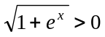
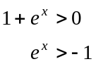
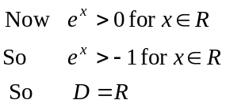
(1 mark)

b. and c.
The y-intercept occurs when 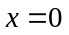
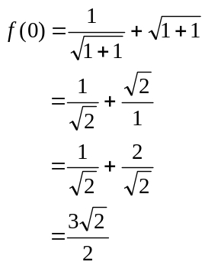
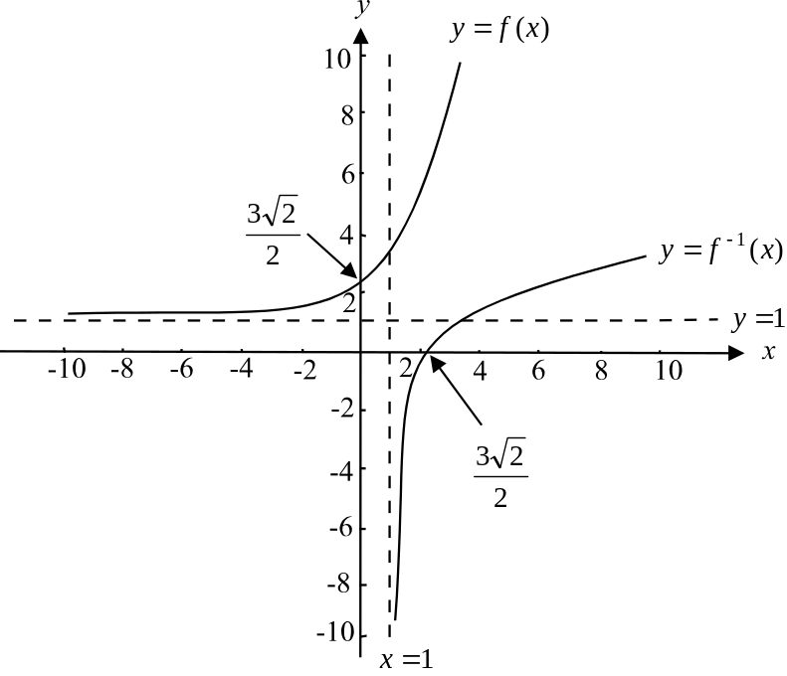

There is an asymptote of 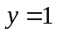since as 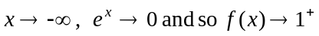.
(1 mark) correct shape of 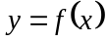
(1 mark) – correct y-intercept
(1 mark) - showing correct asymptote on graph
(1 mark) - showing graph of 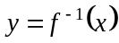 as a reflection
of whatever has been drawn for graph of .

- Stationary points occur when 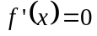.
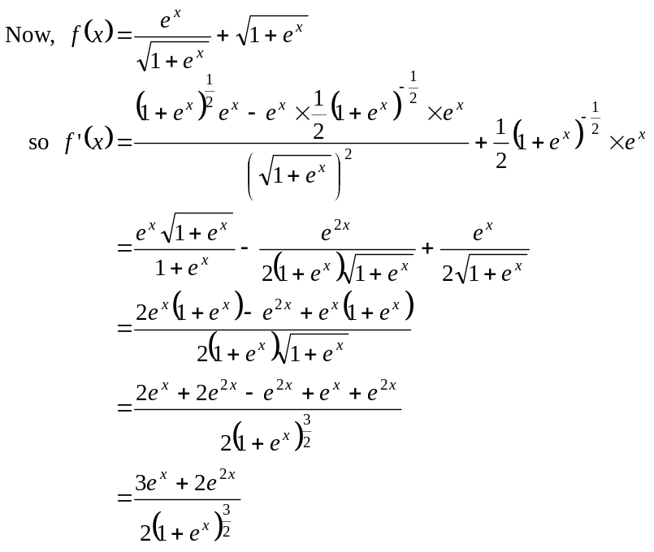
(1 mark)
(1 mark)
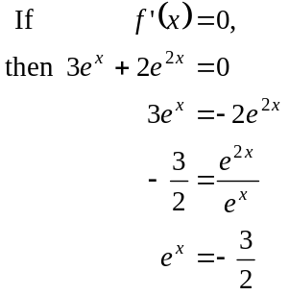
(1 mark)
Since 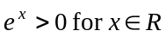, there is no solution to 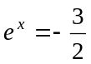 and therefore there is no stationary point on the graph of .
(1 mark) – explanation

- i. 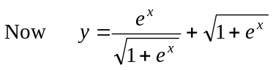
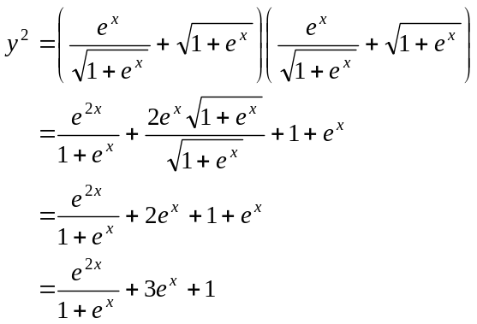
(1 mark)

  - 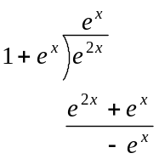
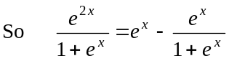
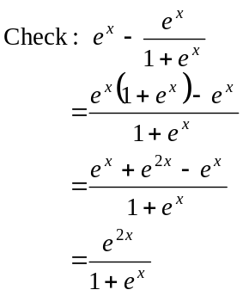
So 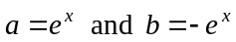.
(1 mark)

- 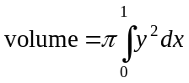
(1 mark)
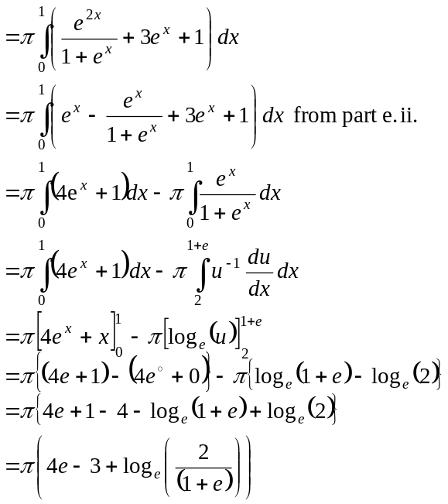
(1 mark)
(1 mark)
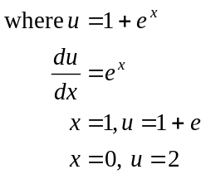
(1 mark)

From part e.i.
(1 mark) change of terminals

Total 16 marks

Question 5

- The feather is released at 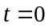. The vertical component above the ground is given by 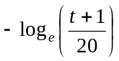.
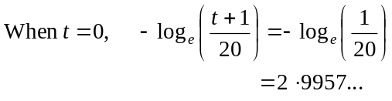
(1 mark)
The feather is dropped from a height of 3m (to the nearest metre).
(1 mark)

- The feather reaches the ground when the component of the coordinate equals zero.
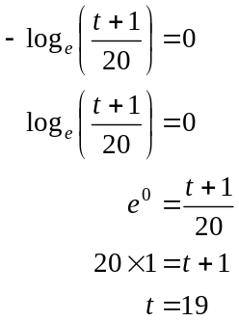
It takes 19 seconds.
(1 mark)

- We need to find 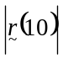.
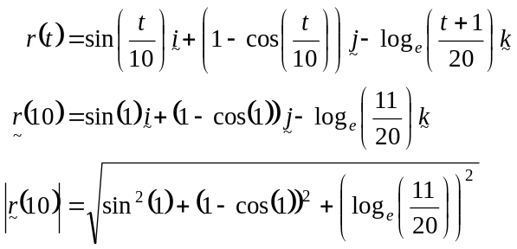
(1 mark)
The feather is 1.13m (correct to 2 decimal places) from the sister at 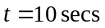.
(1 mark)

- The feather is directly north-east when the component in the direction and the component in the direction are equal; that is when
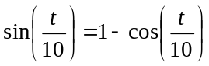 (1 mark)
Using a graphics calculator we see that this happens when 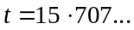.
So, the feather is directly north-east at 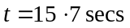 (correct to 1 decimal place).
(1 mark)
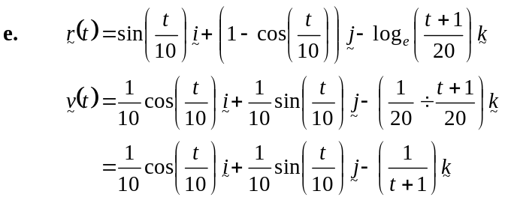
(1 mark)

  - At 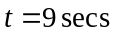,
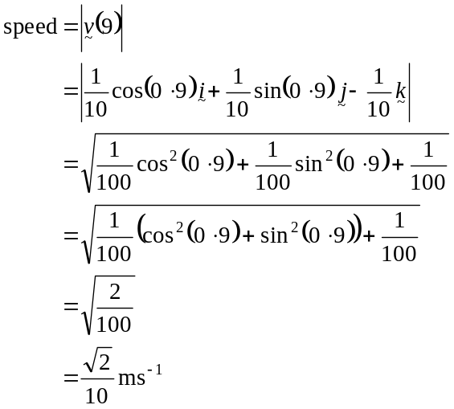
(1 mark)
(1 mark)

  - We need to find the angle between 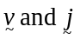.
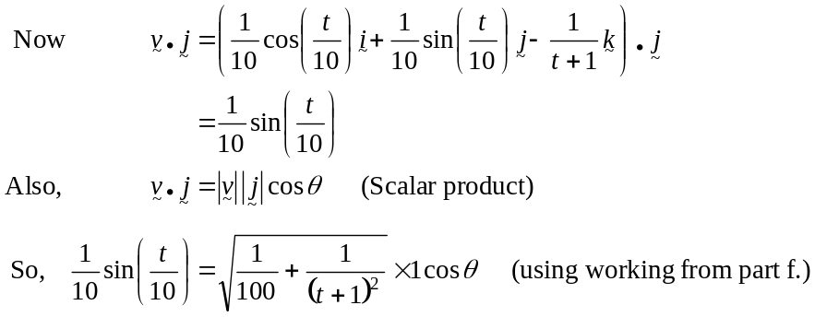
(1 mark)
The feather reaches the ground at 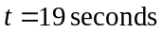.
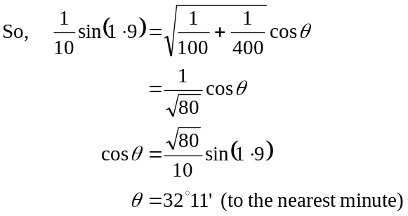
(1 mark)
(1 mark)

  - The component of in the direction gives the position of the feather in the east direction, that is, 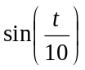.
The maximum value for is 1. (1 mark)
Check when this occurs to make sure that it is before the feather hits the ground.
Now, 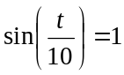 when 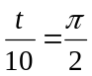; that is when 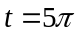
(1 mark)

which is at approximately 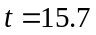seconds. This is before the feather hits the ground.
So the furthest distance east reached by the feather is 1 m.

(1 mark)
Total 15 marks

